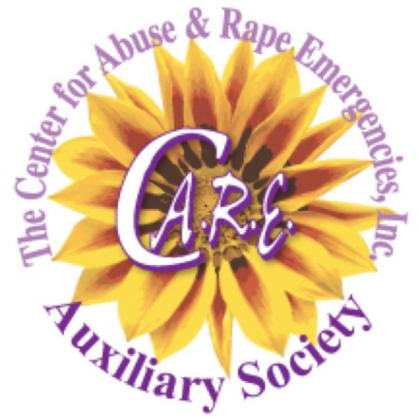
Become a Member of the C.A.R.E. Auxiliary Society
The C.A.R.E. Auxiliary Society is a social, educational, and philanthropic group dedicated to furthering the mission of the Center for Abuse and Rape Emergencies, Inc. and caring for all victims of violent crimes.
Meetings are held the First Wednesday of the month at 6 p.m.
Dues are $50.00 per year
If you would like a C.A.R.E. Auxiliary Society name badge, include an additional $14.00.

Please make checks payable to: C.A.R.E. Auxiliary Society

Please send completed form and check to:
C.A.R.E. Auxiliary Society P.O. Box 496566 Port Charlotte, Florida 33949-6566

Name: ______________________________________________________________________
Address: _____________________________________________________________________
City: ___________________________State _______ Zip Code ________
Phone: __________________________________
Email Address ________________________________________________________________
Please check ONE or MORE events you are interested in helping with
_____ Visani’s Comedy Event (Annual fundraiser event typically held in the Spring)
_____ Dart Tournament (Annual fundraiser event typically held in the Spring)
_____ Cooking with C.A.R.E. (Annual fundraiser event held Spring/Summer)
_____ Golfers Who C.A.R.E. (Annual fundraiser event held in the Fall)
_____ Party for a Cause/Basket Raffle (Annual fundraiser event held in the Fall)
_____ Additional TBD Events
For more information please call 941-639-5499 or visit our website www.carefl.org

